**PYTHON ASSIGNMENT**

Write a Python program to create a person class. Include attributes like name, country and date of birth. Implement a method to determine the person's age.

class Shape:

    def calculate_area(self):

        pass

    def calculate_perimeter(self):

        pass

class Circle(Shape):

    def __init__(self, radius):

        self.radius = radius

    def calculate_area(self):

        return 3.14 * self.radius * self.radius

    def calculate_perimeter(self):

        return 2 * 3.14 * self.radius

class Triangle(Shape):

    def __init__(self, side1, side2, side3):

        self.side1 = side1

        self.side2 = side2

        self.side3 = side3

    def calculate_area(self):

        s = (self.side1 + self.side2 + self.side3) / 2

        return (s * (s - self.side1) * (s - self.side2) * (s - self.side3)) ** 0.5

    def calculate_perimeter(self):

        return self.side1 + self.side2 + self.side3

class Square(Shape):

    def __init__(self, side):

        self.side = side

    def calculate_area(self):

        return self.side * self.side

    def calculate_perimeter(self):

        return 4 * self.side

circle = Circle(5)

print(f"Circle:\nArea: {circle.calculate_area()}, Perimeter: {circle.calculate_perimeter()}")

triangle = Triangle(2,3,4)

print(f"Triangle:\nArea: {triangle.calculate_area()}, Perimeter: {triangle.calculate_perimeter()}")

square = Square(6)

print(f"Square:\nArea: {square.calculate_area()}, Perimeter: {square.calculate_perimeter()}")

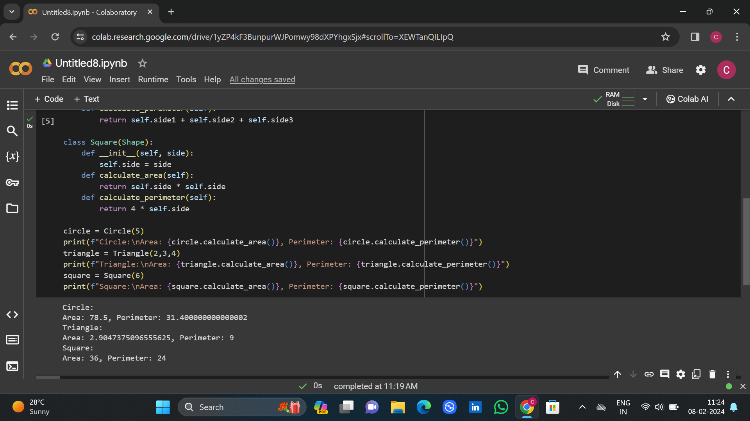

Write a Python program to create a class that represents a shape. Include methods to calculate its area and perimeter. Implement subclasses for different shapes like circle, triangle, and square.

from datetime import datetime

class Person:

    def __init__(self, name, country, date_of_birth):

        self.name = name

        self.country = country

        self.date_of_birth = date_of_birth

    def calculate_age(self):

        today = datetime.now()

        birth_date = datetime.strptime(self.date_of_birth, "%Y-%m-%d")

        age = today.year - birth_date.year - ((today.month, today.day) < (birth_date.month, birth_date.day))

        return age

person1 = Person("Lavanya", "India", "2002-02-18")

print(f"{person1.name}'s age : {person1.calculate_age()}")

